Lagged cross-correlation: USDJPY and USDCAD
Method 12 / daily log returns / K_max=10 / Alpari D1 full available history

Study setup
Logical pair: USDJPY , USDCAD
Broker symbols: USDJPY_i , USDCAD_i
Snapshot: 2026-11-03_majors_alpari_D1
Timeframe: D1
Matched return window: 1999-01-05 to 2026-11-02 (UTC bar dates)
Matched return count n: 7186
Dropped unfinished last bar dated 2026-11-03 UTC after a tick-volume check against the prior complete day.
Lag definition: rho_X->Y(k) = Corr(x_t, y_{t+k}) on matched D1 bars
K_max = 10; headline lag k = 1 (both directions)
Complete matched rows (Excel): USDJPY-USDCAD_Lagged_D1.xlsx
Complete matched rows (HTML table): USDJPY-USDCAD_Lagged_D1_data.html

Method carried forward
Lagged cross-correlation measures Pearson correlation between matched daily log returns of close, ln(close_t / close_t-1), after shifting one series forward by k bars on the matched panel. Quotes are not inverted. rho_{X->Y}(k) = Corr(x_t, y_{t+k}) with n_k = n - k. K_max = 10 is fixed before estimation. The headline is the pre-specified lag k = 1 in both directions. k = 0 is the same-bar side check. The lag inside 1..10 with the largest absolute rho is stored as a descriptive column only; it is not a selected result. This is a linear screen, not proof of forecast edge, economic cause, or a trading signal.

Results (headline k=1)
rho_USDJPY->USDCAD(1): -0.023971 (n=7185)
95% Fisher interval USDJPY->USDCAD: [-0.047068, -0.000848]
rho_USDCAD->USDJPY(1): 0.047782 (n=7185)
95% Fisher interval USDCAD->USDJPY: [0.024686, 0.070827]
Same-bar rho(k=0): 0.027603
Largest |rho| among k=1..10 (descriptive only, not selected): USDJPY->USDCAD k=6 rho=0.026325; USDCAD->USDJPY k=1 rho=0.047782

CCF table
k | rho_USDJPY_to_USDCAD | n_USDJPY_to_USDCAD | rho_USDCAD_to_USDJPY | n_USDCAD_to_USDJPY
0 | 0.02760301 | 7186 | 0.02760301 | 7186
1 | -0.02397096 | 7185 | 0.04778228 | 7185
2 | 0.00888285 | 7184 | -0.00045601 | 7184
3 | 0.00196043 | 7183 | 0.00017272 | 7183
4 | -0.01062209 | 7182 | 0.01605089 | 7182
5 | -0.00461546 | 7181 | 0.01521088 | 7181
6 | 0.02632457 | 7180 | 0.00379228 | 7180
7 | 0.00098662 | 7179 | -0.01651418 | 7179
8 | 0.01241656 | 7178 | -0.00571964 | 7178
9 | 0.01554717 | 7177 | 0.01524989 | 7177
10 | 0.00894578 | 7176 | -0.01276858 | 7176

Conclusion
At the pre-specified lag k=1 for USDJPY and USDCAD, rho_{USDJPY->USDCAD}(1) = -0.0240 (n=7185) and rho_{USDCAD->USDJPY}(1) = 0.0478 (n=7185). Same-bar rho(k=0) = 0.0276. Largest |rho| among k=1..10 is descriptive only: USDJPY->USDCAD at k=6 (0.0263); USDCAD->USDJPY at k=1 (0.0478). This is a linear screen, not forecast proof or a trading signal.

Charts
Daily closes

Daily log returns

CCF both directions k=0..10
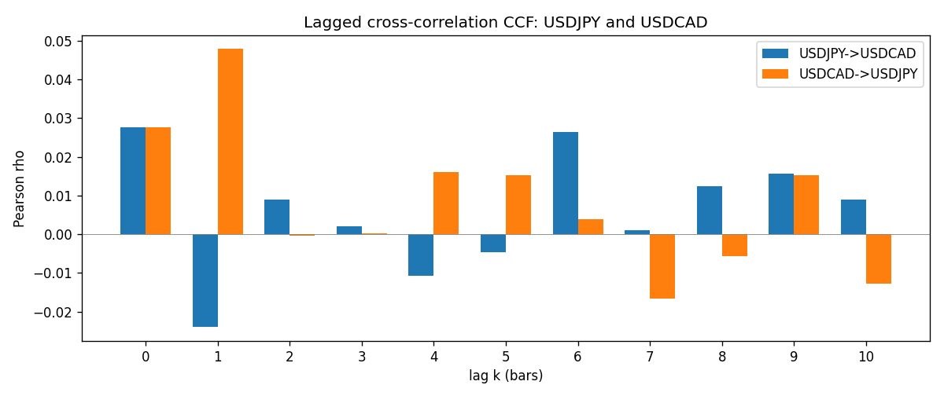

Data report
Every matched row is stored in the sibling Excel workbook named USDJPY-USDCAD_Lagged_D1.xlsx (sheet matched_rows). The CCF sheet holds rho(k) for k=0..10. Embedding all rows as a Word table is impractical; the Word file holds column summaries and the first and last 15 rows.
Columns: time, USDJPY_open, USDCAD_open, USDJPY_high, USDCAD_high, USDJPY_low, USDCAD_low, USDJPY_close, USDCAD_close, USDJPY_tick_volume, USDCAD_tick_volume, USDJPY_spread, USDCAD_spread, USDJPY_real_volume, USDCAD_real_volume, USDJPY_log_return, USDCAD_log_return
Column summaries (matched calculation rows)
column | count | mean | std | min | 25% | 50% | 75% | max
USDJPY_open | 7186 | 113.80748 | 19.222412 | 75.693 | 104.39025 | 110.981 | 120.70625 | 163.824
USDCAD_open | 7186 | 1.266789 | 0.16892251 | 0.9168 | 1.118445 | 1.2985 | 1.37213 | 1.6183
USDJPY_high | 7186 | 114.30511 | 19.284087 | 76.001 | 104.8685 | 111.4395 | 121.2675 | 163.978
USDCAD_high | 7186 | 1.2716872 | 0.16888037 | 0.9336 | 1.122975 | 1.303895 | 1.37655 | 1.619
USDJPY_low | 7186 | 113.28446 | 19.150257 | 75.402 | 103.88 | 110.53 | 120.1715 | 163.628
USDCAD_low | 7186 | 1.2622311 | 0.16895752 | 0.9056 | 1.114125 | 1.293555 | 1.367815 | 1.6102
USDJPY_close | 7186 | 113.82065 | 19.237762 | 75.811 | 104.38275 | 111.018 | 120.69375 | 163.851
USDCAD_close | 7186 | 1.2668036 | 0.16889539 | 0.916 | 1.118165 | 1.29848 | 1.372395 | 1.6137
USDJPY_tick_volume | 7186 | 106329.64 | 179429.89 | 149 | 9948.5 | 53187 | 92874.5 | 1803508
USDCAD_tick_volume | 7186 | 81037.769 | 147318.12 | 37 | 5546.5 | 40944 | 71631 | 1410818
USDJPY_spread | 7186 | 20.270804 | 17.617829 | 0 | 6 | 11 | 30 | 50
USDCAD_spread | 7186 | 23.436682 | 18.263202 | 0 | 9 | 17 | 40 | 60
USDJPY_real_volume | 7186 | 3.4776211e+10 | 1.6092546e+11 | 0 | 0 | 0 | 0 | 3.8834203e+12
USDCAD_real_volume | 7186 | 1.8381818e+10 | 9.6701063e+10 | 0 | 0 | 0 | 0 | 2.5751613e+12
USDJPY_log_return | 7186 | 5.053e-05 | 0.00620694 | -0.03908203 | -0.00319936 | 0.00011986 | 0.0034094 | 0.05184024
USDCAD_log_return | 7186 | -1.555e-05 | 0.00514357 | -0.03859748 | -0.00283709 | 4.741e-05 | 0.00272359 | 0.03436319
First 15 matched rows (selected columns)
time | USDJPY_close | USDCAD_close | USDJPY_log_return | USDCAD_log_return
1999-01-05 | 111.92 | 1.5123 | -0.00017868311 | -0.010131666
1999-01-06 | 112.77 | 1.5118 | 0.0075660159 | -0.0003306769
1999-01-07 | 111.33 | 1.5141 | -0.012851583 | 0.0015202092
1999-01-08 | 110.8 | 1.511 | -0.0047719894 | -0.0020495197
1999-01-11 | 109.02 | 1.5057 | -0.016195423 | -0.0035137769
1999-01-12 | 112.6 | 1.5157 | 0.032310364 | 0.0066194721
1999-01-13 | 113.52 | 1.5226 | 0.0081373171 | 0.0045420214
1999-01-14 | 113.52 | 1.5332 | 0 | 0.0069376546
1999-01-15 | 114.15 | 1.5245 | 0.0055343401 | -0.0056905671
1999-01-18 | 114.16 | 1.526 | 8.7600193e-05 | 0.00098344542
1999-01-19 | 113.52 | 1.5302 | -0.0056219403 | 0.002748513
1999-01-20 | 112.91 | 1.5211 | -0.0053879917 | -0.0059646885
1999-01-21 | 113.87 | 1.5146 | 0.0084664056 | -0.0042823796
1999-01-22 | 114.56 | 1.5184 | 0.0060412564 | 0.0025057712
1999-01-25 | 113.72 | 1.5197 | -0.0073594164 | 0.00085579808
Last 15 matched rows (selected columns)
time | USDJPY_close | USDCAD_close | USDJPY_log_return | USDCAD_log_return
2026-10-13 | 158.305 | 1.4214 | -0.0018932826 | -0.0046395653
2026-10-14 | 158.317 | 1.42356 | 7.5800166e-05 | 0.0015184751
2026-10-15 | 158.024 | 1.41843 | -0.0018524319 | -0.0036101503
2026-10-16 | 157.964 | 1.41357 | -0.00037976126 | -0.0034322068
2026-10-19 | 158.517 | 1.41091 | 0.0034946841 | -0.0018835331
2026-10-20 | 158.16 | 1.40569 | -0.0022546642 | -0.0037066008
2026-10-21 | 158.108 | 1.4045 | -0.00032883504 | -0.00084691787
2026-10-22 | 156.755 | 1.40081 | -0.0085942669 | -0.0026307268
2026-10-23 | 156.81 | 1.40085 | 0.00035080446 | 2.85545e-05
2026-10-26 | 157.458 | 1.40093 | 0.0041238746 | 5.7106554e-05
2026-10-27 | 157.894 | 1.40449 | 0.0027651658 | 0.0025379458
2026-10-28 | 157.743 | 1.39911 | -0.00095679538 | -0.0038379274
2026-10-29 | 157.683 | 1.39895 | -0.00038043789 | -0.00011436495
2026-10-30 | 157.516 | 1.39751 | -0.0010596481 | -0.0010298736
2026-11-02 | 157.933 | 1.39837 | 0.0026438521 | 0.00061519094

